|  | **Product specification form** |
| --- | --- |
| **Product: Organic Cacao Powder 10/12 Natural** |

| **FINISHED PRODUCT SPECIFICATION** | | | **Spec No. SPEC137** |
| --- | --- | --- | --- |
| **General Information** |  |  | Date of review:  13.11.2024, Issue 1 |
| **Product Title** | **Organic Cacao Powder 10/12 Natural** | | |
| **Packaging format** | Bulk: paper sacks - 25kg | | |
| **Available Quantities** | Bulk: 25kg | | |

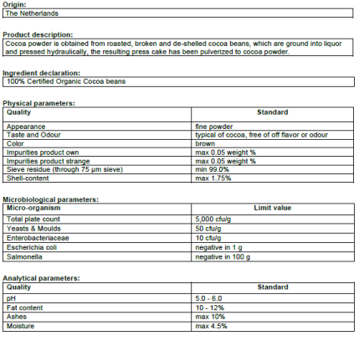

|  | **Product specification form** |
| --- | --- |
| **Product: Organic Cacao Powder 10/12 Natural** |

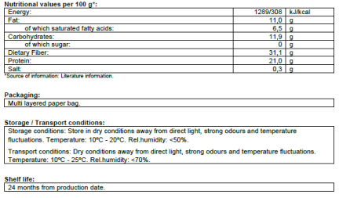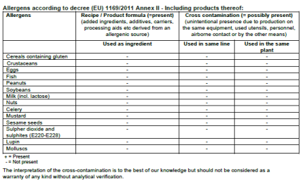

| **INFORMATION ABOUT GMO AND IONIZATION** | |
| --- | --- |
| GMO | The product is not GM does not contain GMO. |
| Ionization | The product is not subjected to ionizing radiation |

| **Alergens:-When purchased in bulk size original packaging, manufacturer allergen policy will apply.**  **When purchased in quantities that need re-packaging, our allergen policies will apply.** | | | | | | |
| --- | --- | --- | --- | --- | --- | --- |
| **Component** | **Manufacturer** | | | **Nuts in Bulk**  **( Applies when bought in small quantities that need re-packaging )** | | |
| **In Product** | **Processed in**  **Same Equipment** | **Handled on Site** | **In Product** | **Processed in Same Equipment** | **Handled on Site** |
| Cereals containing GLUTEN and products thereof | NO | NO | NO | NO | **YES** | **YES** |
| EGGS or its derivatives | NO | NO | NO | NO | NO | NO |
| FISH or its derivatives | NO | NO | NO | NO | NO | NO |
| CRUSTACEANS / SHELLFISH | NO | NO | NO | NO | NO | NO |
| MOLLUSCS | NO | NO | NO | NO | NO | NO |
| PEANUTS or derivatives | NO | NO | NO | NO | **YES** | **YES** |
| SOYA BEANS or derivatives | NO | NO | NO | NO | **YES** | **YES** |
| MILK (LACTOSE) or its derivatives | NO | NO | NO | NO | **YES** | **YES** |
| NUTS , tree nuts: | NO | NO | NO | NO | **YES** | **YES** |
| CELERY, including celeriac and its derivatives | NO | NO | NO | NO | **YES** | **YES** |
| MUSTARD, referring to all parts of the plant and derivatives thereof | NO | NO | NO | NO | **YES** | **YES** |
| SESAME SEEDS or derivatives | NO | NO | NO | NO | **YES** | **YES** |
| SULPHITES >10ppm – Sulphite quantity to be given in ppm | NO | NO | NO | NO | **YES** | **YES** |
| LUPIN seeds or derivatives | NO | NO | NO | NO | NO | NO |